The Heart And Vessels

The Heart:
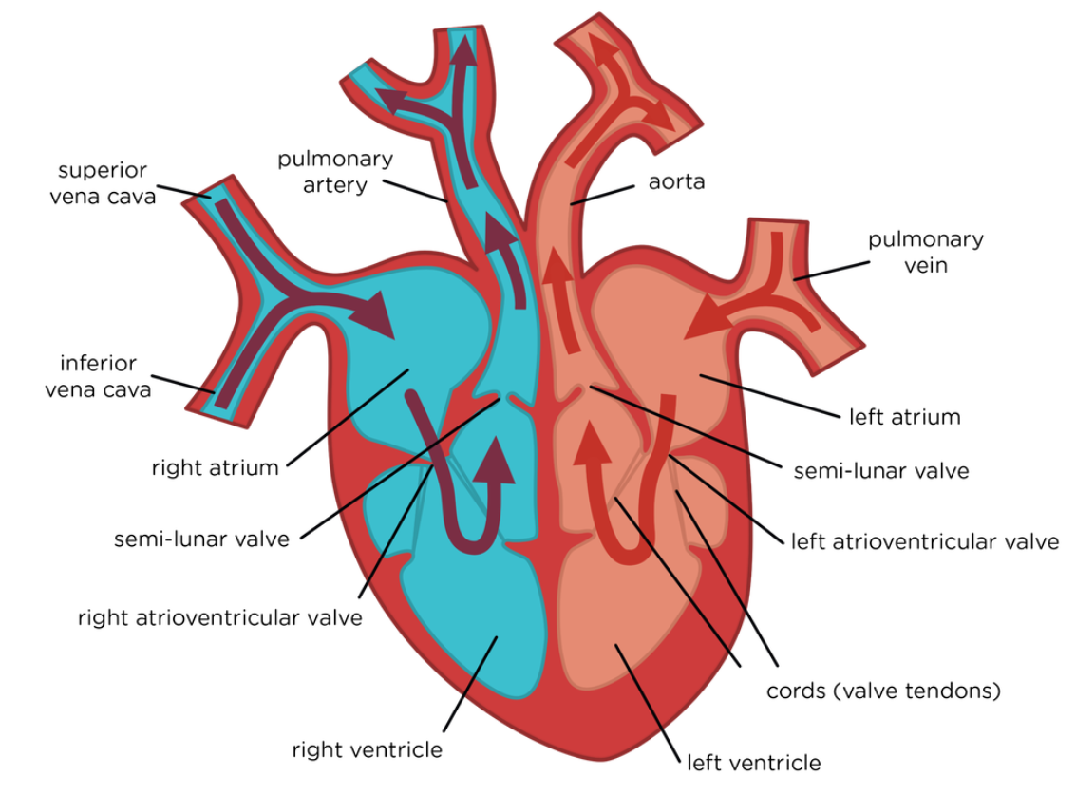
The left side is thickest, as it needs to be strong enough to pump blood to the whole body, rather than just to the lungs as the right side does.
The ventricles are thicker than the atria, as the atria need to pump blood only to the ventricles, but the ventricles pump the blood a lot further.

Atrioventricular valves are opened when the pressure in the atrium is higher than the pressure in the ventricle, so blood cannot flow back into the atria when the ventricle contracts.

The semi-lunar valves are opened when the pressure in the ventricle is higher than the pressure in the artery. The aorta and the pulmonary arteries are the only arteries that have valves. The valves are inside the arteries, not inside the ventricles.

The Cardiac Cycle (In Order):
Atrial Systole:
- Atria contract
- A-V valves pushed open by pressure
- Blood pushed to ventricles
- S-L valves closed to stop backflow
Ventricular Systole
- A-V valves close to stop backflow – no pressure to open them
- Ventricles contract
- S-L valves open by pressure
- Blood pushed through Arteries
Cardiac Diastole:
- Atria relaxed and filling
- A-V valves partially open, so ventricles relaxed partially filling
- S-L valves closed to stop backflow

This process then repeats.

